 |  | Workplace Health Services  Health Promotions Programs  Phone: 604-827-4713  Fax: 604-827-4588  Email: kelly.mcintosh@ubc.ca

Workplace Health Services
Map and Directions

David Strangway Building
Ste. 310 – 5950 University Boulevard
Click here for Wayfinding at UBC Map and Directions

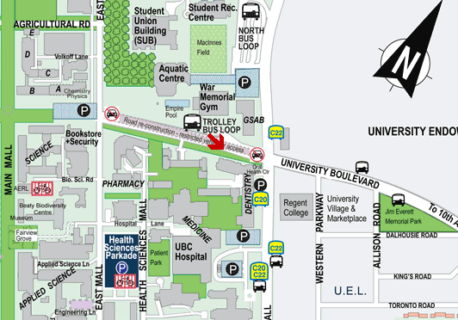
INSIDE THE BUILDING

- Take the elevator to the 3rd Floor.
- Follow the signs to the UBC Health Clinic.
- Tell the front receptionist you have an appointment with Workplace Health Services
- The receptionist will direct you down the hall to our offices.

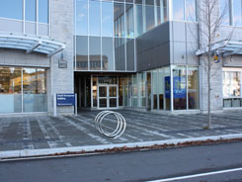
Shopper’s Drug Mart

