Manager’s **Offboarding Guide**

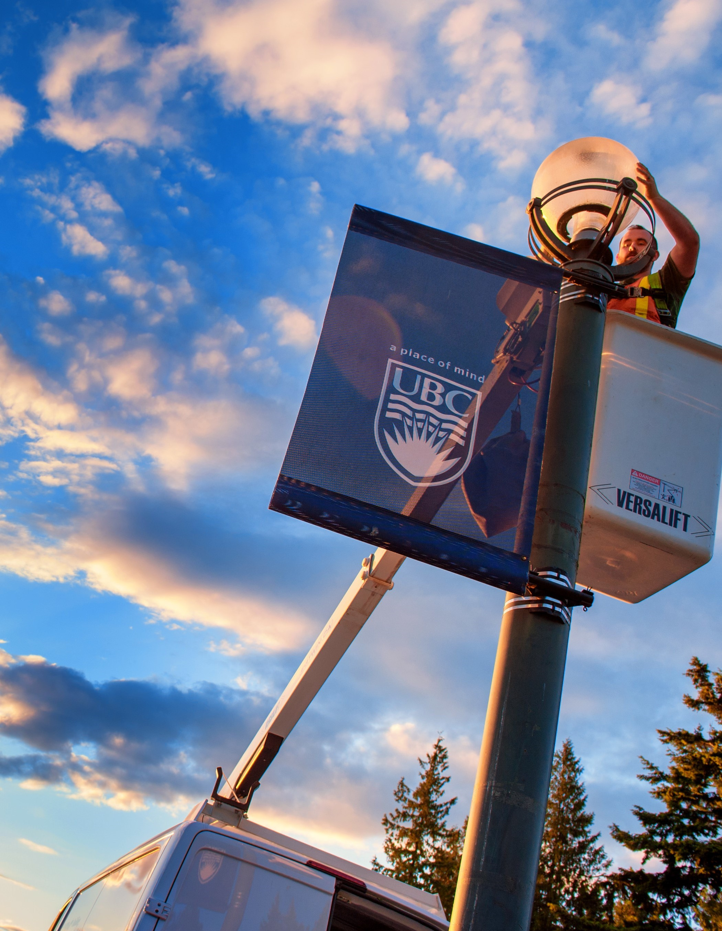

A MEMBER OF YOUR TEAM IS LEAVING UBC

Faculty and staff leave UBC for a variety of reasons – whether it is a career change, retirement, relocation, or other circumstances. Regardless of the reason for leaving, a thoughtful and consistent offboarding process is essential to ensure a smooth transition for both the departing member and the team they leave behind.

HOW TO USE THIS GUIDE

This Manager’s Offboarding Guide is designed to provide managers with clear procedures to follow to ensure all outstanding matters and offboarding tasks are resolved prior to their team member’s departure from UBC.

There may be additional offboarding processes or tasks specific to your team member based on their role, department/unit, work arrangement and so on. As their manager, update this checklist based on your needs.

*You can access the latest version of this Manager Offboarding Guide template from the* [***Offboarding***](https://hr.ubc.ca/managers-admins/retirements-and-resignations/offboarding-managers) *page on the HR website (CWL login required). This guide will be updated regularly, so ensure you visit the HR website for the most current version.*

**CONTENTS**

*(The Table of Contents is clickable. Simply click on any section to jump directly to it.)*

PRIOR TO THEIR DEPARTURE 2

1. Ensure relevant termination processes are completed in Workday
2. Communicate the departure of your team member to relevant parties
3. Prepare for your team member’s departure

ON THE LAST DAY 4

AFTER THEIR DEPARTURE 4

# Prior to their departure

Is your team member leaving UBC or just transferring to a new team within the university?

Consider how this will inform the level of offboarding required prior to their departure from your unit – skip any offboarding tasks that do not apply to internal transfers within UBC.

1. Ensure relevant termination processes are completed in Workday

**Submit a termination request to your Faculty/Department HR or administrator for processing in Workday,** **with a copy of the resignation letter or related documentation.** This Workday Business Process will prompt the termination of payroll, benefits, IT access, and other accounts linked with their Workday profile after their last day of work.

*Failure to terminate an employee on or before their last day of employment in Workday can result in overpayments and unauthorized systems access beyond their last day of employment.*

**Reconcile all outstanding expenses incurred by your team member.** Ensure that they submit a final expense report for any out-of-pocket and UBC Visa Card expenses, if applicable, for processing in Workday prior to their departure to avoid payment delays or complications.

**If applicable, ensure your team member cancels and returns any UBC Visa Cards.** Credit Card cancellations are processed in Workday through [these steps](https://ubc.service-now.com/selfservice?id=kb_article&sys_id=81d0af3293c392905a9f30edfaba10ce&table=kb_knowledge) (CWL required).

**If applicable, remove Workday delegations and close spend authorizations assigned to your team member.** Reassign any delegations and transactions awaiting action in Workday. Follow these steps to [remove delegations](https://ubc.service-now.com/selfservice?id=kb_article&sys_id=6a8801a5478baa14d8618571516d43fc&table=kb_knowledge) or to [close spend authorizations](https://ubc.service-now.com/selfservice?id=kb_article&sys_id=799df8179353de505a9f30edfaba1051&table=kb_knowledge) (CWL required).

1. Communicate the departure of your team member to relevant parties

**Coordinate the transition of key tasks and responsibilities from your departing team member to new owner(s),** including the transfer of any files/folders, processes, ongoing tasks, login credentials of shared accounts, and any other applicable information essential to the role.

**Communicate the departure of your team member to relevant parties in your department.** Your Faculty/Department may have a channel or procedure for communicating departures, such as through an internal newsletter or townhall meeting.

**If applicable, your Faculty/Department HR or administrator may invite your team member to complete an Exit Interview.** They may also receive an Exit Survey to complete in Workday.

1. Prepare for your team member’s departure

**Prepare a card, gift, and/or gathering for your departing team member’s last day, if appropriate.** Provide advance notice to their colleagues about joining any planned activities.

**Remind your departing team member about key information they need to know prior to leaving UBC.** Examples could be:

* + Update their personal and **contact information** in Workday, if applicable.
  + Cancel any **parking permits** with [UBC Parking](https://parking.ubc.ca/help-support), if applicable, to avoid auto-renewals or to claim any potential refunds for unused time on long-term permits.
  + Ensure that outstanding **benefits claims** are submitted prior to leaving UBC. Visit this [UBC Benefits](https://hr.ubc.ca/benefits/life-events-and-your-benefits/leaving-ubc) webpage for information about benefits coverage end dates.
  + Ensure that outstanding **professional development fund claims** are submitted prior to leaving UBC. Visit this [UBC HR](https://hr.ubc.ca/career-development/professional-development-funding) webpage for information about PD Funds. *Faculty or staff who have given their notice of resignation are no longer eligible to access funding for new PD expenses.*
  + Visit the [UBC Finance](https://finance.ubc.ca/pay-taxes/former-employees/) website for information about accessing **pay slips, tax slips**, and employment verification letters for up to 18 months after leaving UBC.
  + Visit this [UBC HR](https://hr.ubc.ca/working-ubc/retirement-and-leaving-ubc/leaving-ubc) webpage for information about leaving the Faculty or Staff Pension Plan and options available for receiving their **accrued pension benefit**.

**If applicable, ensure your team member cancels all recurring/future meetings and room bookings they created in Outlook.** Resend any recurring/future meeting invites if needed.

# On the last day

Did your team member use department-specific assets or systems to perform their job?

Be sure to notify any relevant department administrators to ensure that department-specific access and/or assets are deactivated and retrieved upon your team member’s departure.

**Where applicable, request your departing team member to add an out-of-office message to their email account and/or change their voicemail message.** Inform your team member whether any alternate contact(s) should be included in the out-of-office message.

**Arrange the deactivation and/or retrieval of department-specific and UBC assets from your team member on their last day.** In some departments, you may be able to arrange these with your department/office administrator. Examples could be:

* + Building access cards, keys and codes, or security identification
  + Office equipment (e.g., laptop, cell phone, data devices, ergonomic equipment)
  + Work tools or equipment, protective gear, uniforms, or name badges

**Ensure that your departing team member removes all personal belongings from their office, workstation, locker, and/or fridge.** If needed, schedule an alternate day/time with your team member to retrieve their personal belongings from work.

**If appropriate, offer to be a professional reference for your departing team member in the future.** Provide your contact information (email address and/or phone number) as needed.

# After their departure

**Request your IT administrator to revoke your departed team member’s access to UBC and/or department-specific systems and assets.** In some departments, you may be able to arrange these with your department/office administrator. Examples could be:

* + Computer(s), laptop(s), mobile phone(s), and/or other data devices
  + UBC or department-specific email address, shared drives/files, private networks, etc.

**If applicable, ask your Faculty/Department administrator to update any departmental directories, mailing lists, and/or website(s).**