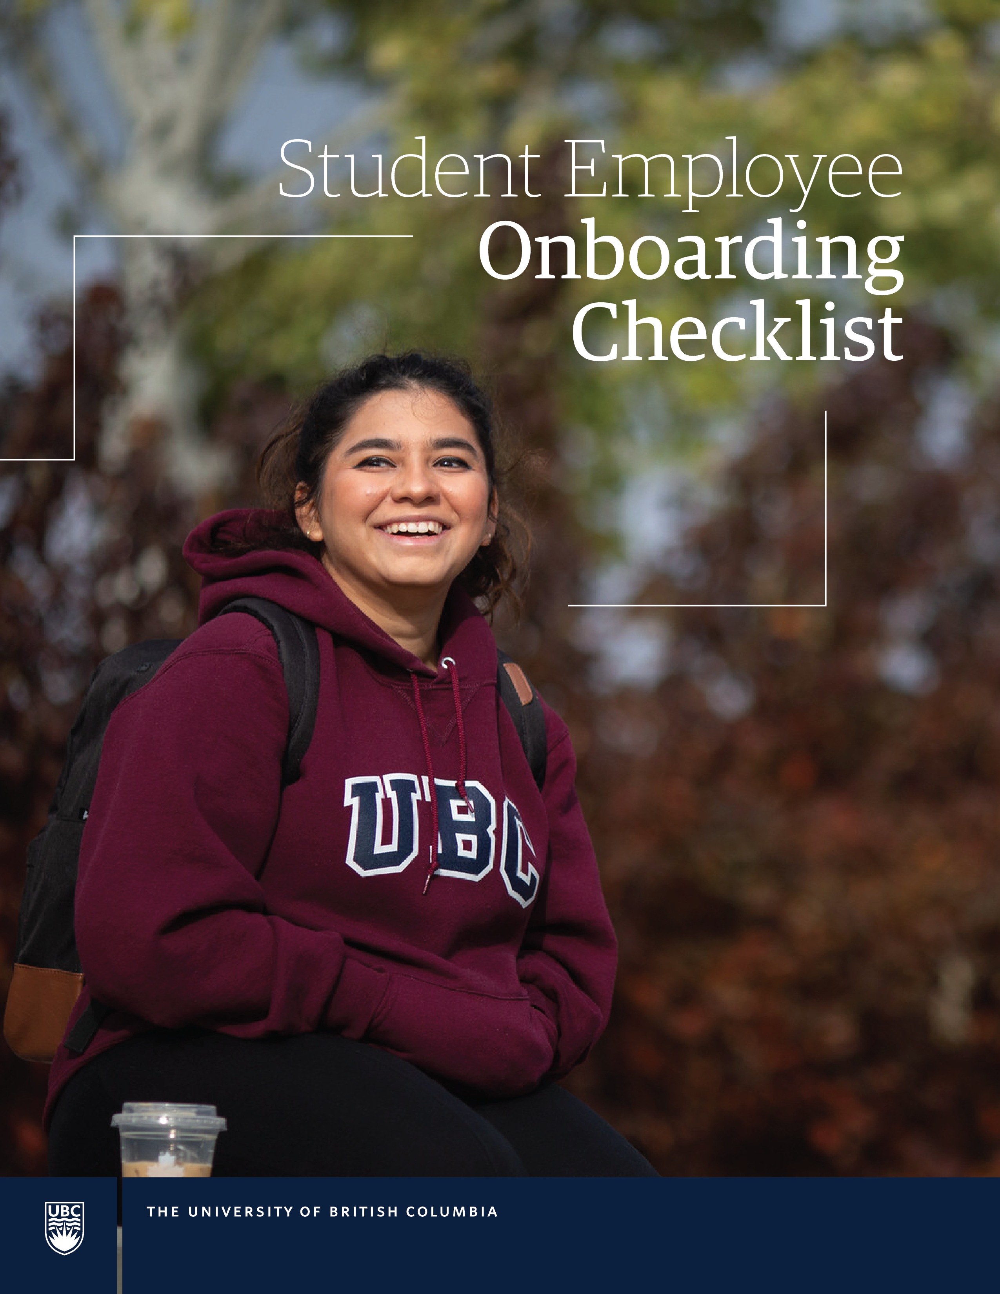

Student Employee Onboarding Checklist

2023

Baluk, Melissa

2023

Student Employee Onboarding Checklist (*Template*)

**Managers and supervisors – How to use this template**

This checklist template is designed to help you make sure that you effectively onboard new student hires and that you’ve covered key details relevant to the position. It is designed to be a starting point for your local onboarding plan. Please review and customize as needed.

*For more information on Hiring A Student Employee and Managing A Student Employee, visit the* [*Recruiting and Hiring Student Employees*](https://hr.ubc.ca/managers-admins/recruiting-and-hiring/student-employees/managing-student-employees) *page, or the* [*Onboarding New Employees*](https://hr.ubc.ca/managers-admins/onboarding-new-employees) *page on the HR website (note, CWL required for these two pages).*

**✓ Check the completion of tasks.**

**✓ Skip the items that are not applicable.**

**✓ Once completed, keep checklist on file for your records.**

Before your student employee starts

* **Complete Direct Deposit (banking) information for new student employee in Workday:**

Transit #

Institution #

Account #

Direct Deposit allows funds to be delivered directly into the student employee’s bank account. This is currently the only way for a student to receive their pay. Direct deposit is convenient, safe, and fast.

* **Complete Payroll / HR information for new student employee in Workday:**

Legal name

SIN & birthdate

Address, phone, email

Job requisition number

Job classification / title

Start date (1st day worked)

Salary / pay rate: Ensure compensation has a rate of pay and is not zero

* Initiate IT Setup (start as soon as your new student employee has accepted the position to allow for setup time).

Ensure student has [CWL account](https://activate.id.ubc.ca/iamweb/) updated and has [set up Enhanced CWL](https://privacymatters.ubc.ca/enhancedcwl) for security.

* Send Onboarding Package to your new student employee and make any required training arrangements.

Ensure that you include:

* Student Employee Handbook
* Workday Essentials for Student Workers
* Safety training

These resources can be found on the [Managing Student Employees](https://hr.ubc.ca/managers-admins/recruiting-and-hiring/student-employees/managing-student-employees) page.

* Arrange your schedule to spend time with the new student employee on their first day and in the first week.
* Make immediate team aware of the arrival of the new student employee and their role.
* Ensure workspace is set up, clean and ready with all appropriate supplies and tools.
* Arrange building/room Access (keys, access card, alarm codes).

On your student employee’s first day

* Meet and welcome the new student employee and discuss their schedule for the first day/week.
* Review [payroll information](https://finance.ubc.ca/payroll). This includes their primary address, payment election, direct deposit task and tax elections. *Not completing this in a timely manner could impact their pay.*
* **Review departmental standards.** This includes out-of-office replies, email etiquette and UBC signature, customer-facing communications, leave usage, absence reporting procedures, including late arrivals and calling in sick, etc.
* **Review work and break schedule** (refer to relevant collective agreement) and departmental policy on signing in/out or end-of-day procedures**.**
* **Provide orientation to their physical workspace.** Ensure they have the required office supplies and tools to do their work successfully.
* **Provide orientation to their work-related technology.** This includes computer and telephone (if applicable), systems access, email, and voicemail.
* **Review job description, key skills, competencies, performance discussions, schedule regular meetings, 1:1 meeting, and establish mutual expectations.** Allow time for student employee to ask any questions at this time.

During your student employee’s first week

* **Review department website/intranet, shared drives, filing system, administrative work practices, etc.**
* **Review applicable site-specific safety procedures.**
* **Review UBC policies** **and procedures:**
  + [UBC Statement on Respectful Environment](https://hr.ubc.ca/sites/default/files/wp-content/blogs.dir/14/files/UBC-Statement-on-Respectful-Environment-2014.pdf)
  + Policy GA4 – [Records management](https://universitycounsel.ubc.ca/policies/records-management-policy/)
  + Policy SC1 – [Health and Safety](https://universitycounsel.ubc.ca/policies/health-and-safety-policy/)
  + Policy SC5 – [Snow](https://universitycounsel.ubc.ca/policies/extreme-environmental-conditions-policy/)
  + Policy SC7 – [Discrimination](https://universitycounsel.ubc.ca/policies/discrimination-policy/)
  + Policy SC13 – [At-Risk Behaviour](https://universitycounsel.ubc.ca/policies/at-risk-behaviour-policy/)
  + Policy SC14 – [Information Systems](https://universitycounsel.ubc.ca/policies/information-systems-policy/)
  + [Security Standards](https://cio.ubc.ca/information-security/policy-standards-resources)
  + **Review relevant strategic initiatives:**
* [UBC’s Strategic Plan](https://strategicplan.ubc.ca/)
* [Focus on People](https://focusonpeople.ubc.ca/)
* [Strategic Equity & Anti-Racism Framework](https://equity.ubc.ca/stear-framework-and-roadmap-for-change/)
* [Indigenous Strategic Plan](https://indigenous.ubc.ca/indigenous-engagement/indigenous-strategic-plan/)
* [Wellbeing Strategic Framework](https://wellbeing.ubc.ca/framework)
* [Climate Action Plan](https://planning.ubc.ca/cap2030)